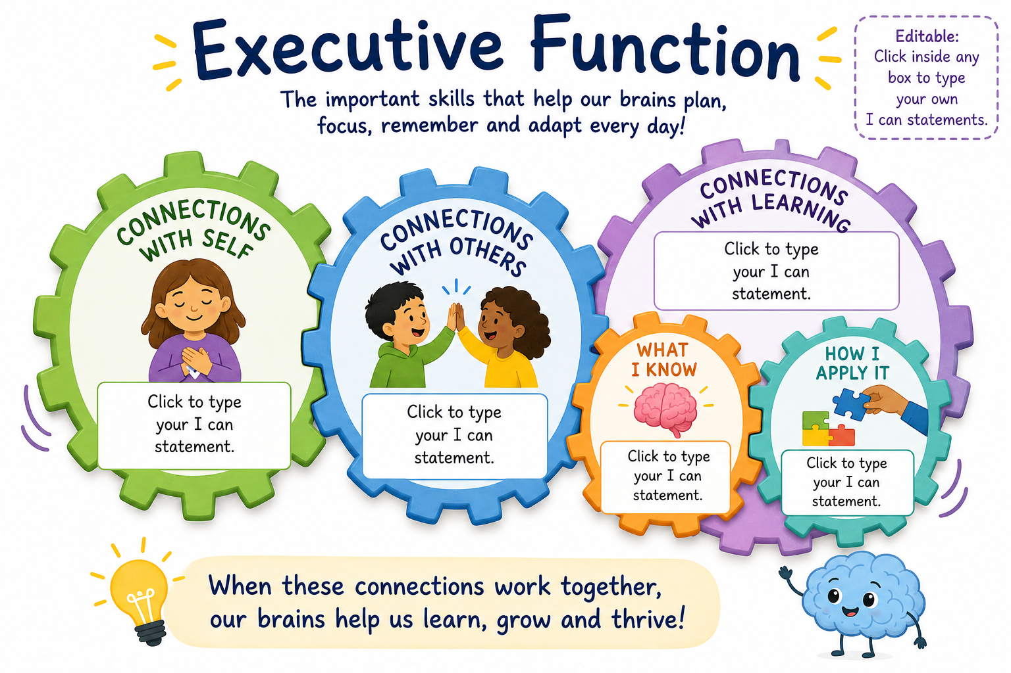
I use my learning in my play
I solve problems in different ways
I use what I know in new situations
I remember things I have learned
I can talk about my ideas
I can show what I understand
I can talk about my feelings
I try to calm myself when I feel upset
I feel proud when I try my best
I try new activities and challenges
I ask questions when I am unsure
I keep going even when something is tricky
I play kindly with my friends
I share and take turns
I listen when others are speaking
Reception
I use what I learn in different activities
I solve problems in different ways
I apply my learning to real-life situations and play
I can recognise and talk about my feelings
I know ways to calm myself when I feel upset or worried
I can set simple goals and feel proud when I achieve them
I can remember key facts
I can explain my ideas using what I have learned
I can make links between different things I know
I try hard even when learning feels difficult
I ask questions to help me understand more
I enjoy learning new skills and improving my work
I work well with others in a team
I listen carefully and respect other people’s ideas
I solve disagreements calmly and fairly
KS1
I use what I learn in different subjects
I solve problems independently in different ways
I apply my learning to real-life situations
I can remember key facts and information
I can explain my ideas in detail using what I have learned
I can make links across subjects
I can work well with others in a group or team.
I listen to others and respect their ideas.
I can solve disagreements calmly with help if needed.
I can name and talk about my feelings.
I know how to help myself feel calm when I am upset or worried.
I can set simple goals and feel proud when I achieve them.
I try my best even when work is hard.
I ask questions to improve my work
I enjoy editing my work to show improvement
LKS2
I show resilience when learning is challenging.
I ask thoughtful questions to deepen my understanding.
I enjoy developing my skills and improving the quality of my work.
I work effectively and responsibly in a team.
I listen carefully and consider different viewpoints.
I can resolve disagreements fairly and independently.
I apply my learning across different subjects and situations.
I choose the most appropriate strategy for a situation or problem
I transfer my learning to real-life contexts and unfamiliar situations.
I can recall key information accurately and confidently.
I can explain my thinking clearly using what I have learned.
I can make and explain connections between different ideas and subjects.
I can recognise, explain and manage my emotions.
I use strategies to stay calm when I feel stressed or upset.
I can set my own goals and reflect on my achievements.
UKS2

